Removing the C32 center dash panel and radio

These are not my instructions, they were garnered from the web, I merely pasted them onto a doc file. There is Air Bag wiring nearby. If you feel uncomfortable with that fact I suggest you don’t proceed. Take your time: be careful not to break the plastic locks and scratch your dash panels. The first time you do this it will take about 30 minutes, the next time may well be half that time because you will have the correct tools and will understand exactly what you need to do.

There probably is airbag wiring nearby, you should not tamper with that, so be very sure you know what you are doing with the wiring.

If you study the Mercedes Documents (pictured below) for several minutes before you start, you will understand them as you proceed.

Tools needed:
Torx driver small-med #15 or #20?,
a thin steel tool such as a 1/2 inch wide steel ruler,
small flat-blade screwdriver (tweaker driver style)
regular, “long” flat blade screwdriver
small, bright flashlight

Removing the center dash panel to get to the radio

(These are installation notes, I suggest you follow the actual MBZ docs 1 page below).
Remove Vent Assembly: The hardest part is the first, the upper center vent assy. It has to come out. Look inside the vent itself: Find the locks on the top/sides, they allow the vents to rotate fully, farther up and down than normal. Phase 1: Release locks, rotate the vents fully up, remove the torx screws on the bottom. Phase 2: Unlock again, rotate fully down, and hold the top “teeth assy’s”, pull firmly to remove the whole vent assembly. You will soon appreciate the tight fit and the German Engineering. It is a little tricky to get the center vent assembly out. You need to keep the top latches pressed down as you pull out the assembly. They have several "teeth" that grip the lip molded into the dash piece above, so you need to keep some pressure on the unlock tabs as you slide it out. It's a tight fit, but if you pull straight out and gently rock it, it will come out. Disconnect the electrical connector that supplies power for the backlit controls.
Removing the aluminum trim piece: Stop the car with the gear selector in “N” Remove ashtray. There are two spring “Metal Clip” locks (which are deep and thus hard to see) on either side inside the ashtray receiver area/in the gap above the Ashtray door. Use a flashlight to locate them. Careful not to scratch your ashtray door. Lever them DOWN to UNCLIP these spring clips. Panel should now be loose. Remove the panel. Watch where you disconnect cables, pay attention else they can be reassembled incorrectly.
The radio itself is held in place by two torx screws (one on each side). For this dash/radio removal work the torx screws are different, keep each torx type separated from the others. Once you remove those screws, the radio slides right out. After you slide out the radio, the pocket below it also slides out (no screws holding it in). Be careful that your fiber optic lines don't kink while you're sliding out the radio. It's a little tight in there. Be especially careful not to kink a line during re-insertion of the radio.

Actual Mercedes instructions follow below:

Removing the radio is done in three major steps:
- Center Air Nozzle (Vent) Removal, (this is the black, plastic 2-channel vent directly above the radio). This step is a little difficult.
- Center Console Cover Removal, (this is the metal panel surrounding the radio itself). This step is a bit easier.
- Radio Removal. Mechanically this step is very easy
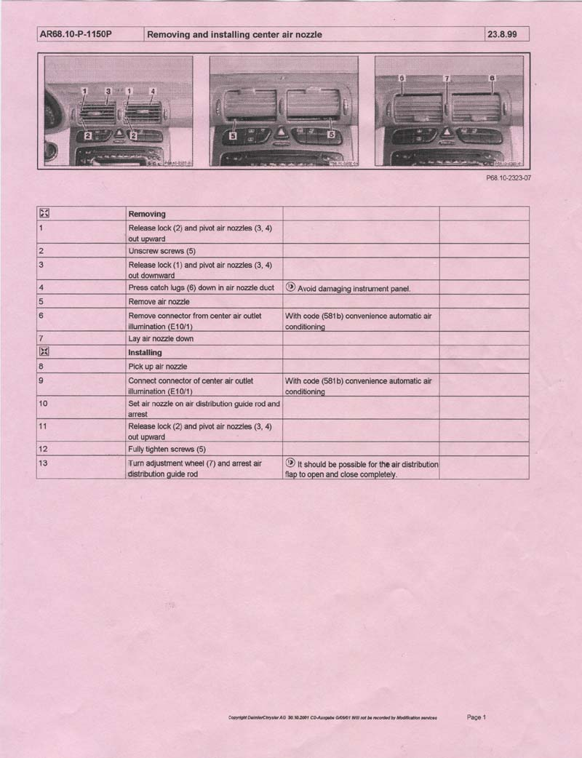
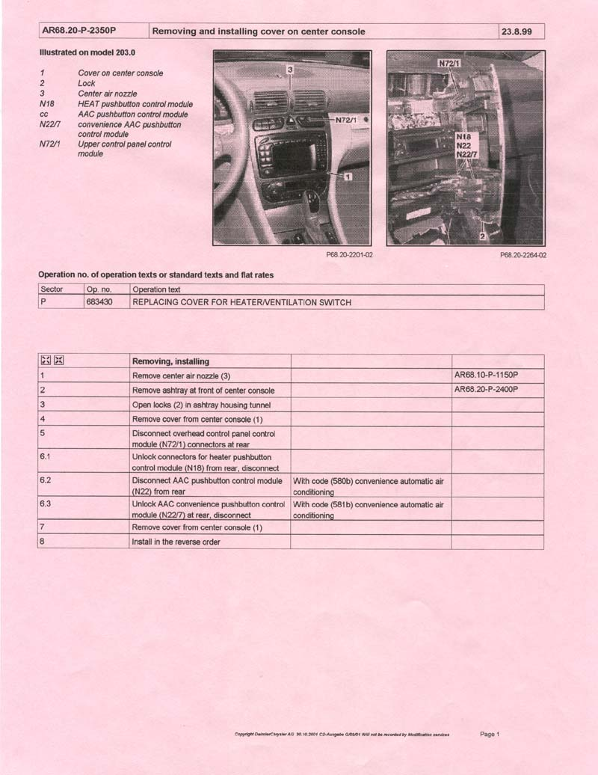
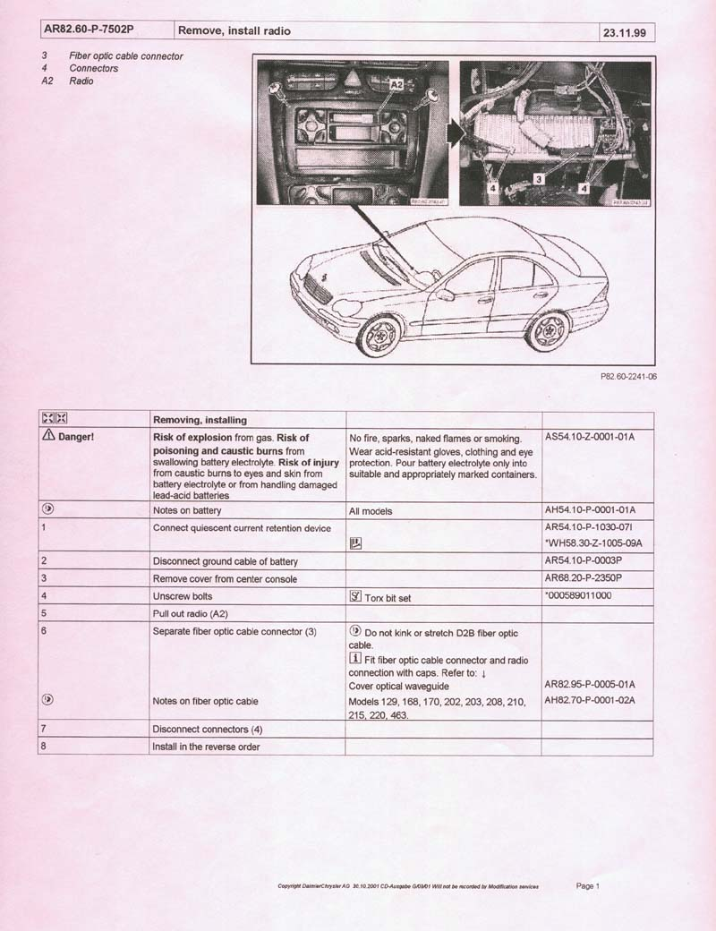

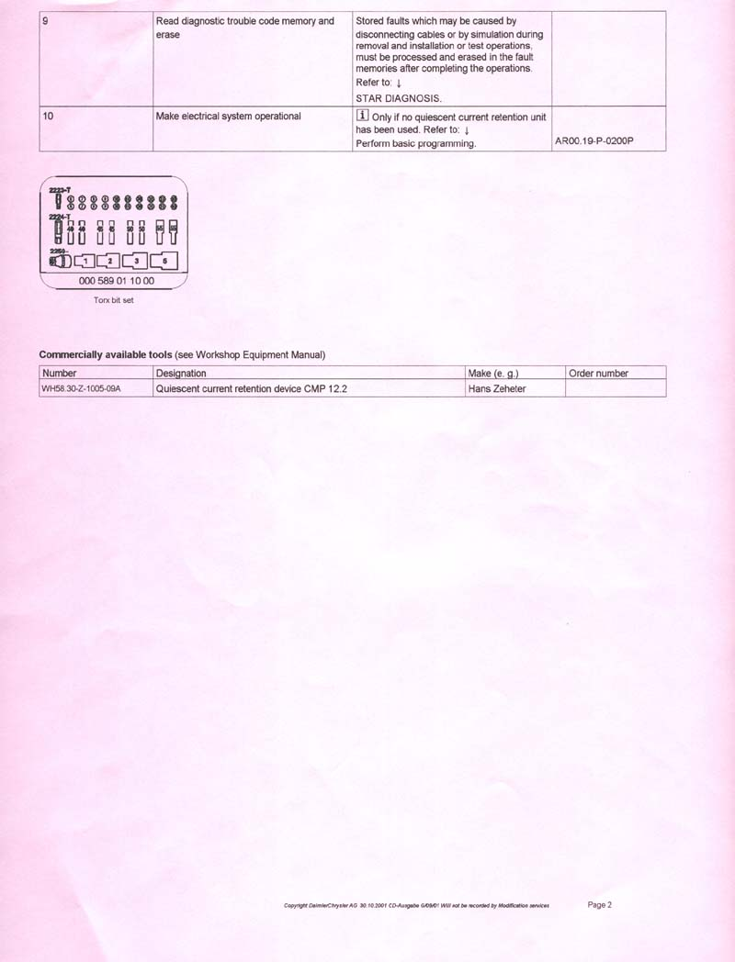

Installing the CD changer UNTESTED steps:
1. | Remove the radio.
2. | Remove the three CD changer transport keys.
3. | Verify that the suspension spring setting is "H" (horizontal).
4. | Affix the three adhesive dust covers from the kit over the transport holes on the bottom of the CD changer.
5. | Mount the CD changer to the mounting bracket with four M4 X 6 machine screws.
6. | Use a knife to cut out the perforated knock-out from inside the CD changer compartment left side.
7. | Feed the CD changer power cable through the newly created opening and into the CD changer compartment.
8. | Feed the fiber optic cable through the same opening into the CD changer compartment.
9. | Connect the power and fiber optic cables to the back of the CD changer.
10. | Carefully secure both cables in the CD changer bracket clip.
11. | Slide the CD changer assembly completely to the left of the compartment until the bracket tab inserts into the compartment slot.
12. | Secure the CD changer assembly at the right mounting tab with a screw.
13. | Reinstall the radio in reverse order of removal.

